State of Michigan

OBRA Automation suite

Workflow-4

On Demand Print 3877 and 3878 Forms

**Workflows with screenshots:**

Step 1:

Facility User logs in. Click on 3877-78 Module

Step 2:

Search for a consumer that has 3877 and 3878 forms. Use the search criteria below. Last name = a, Exemption Criteria = Dementia. Click on Search.

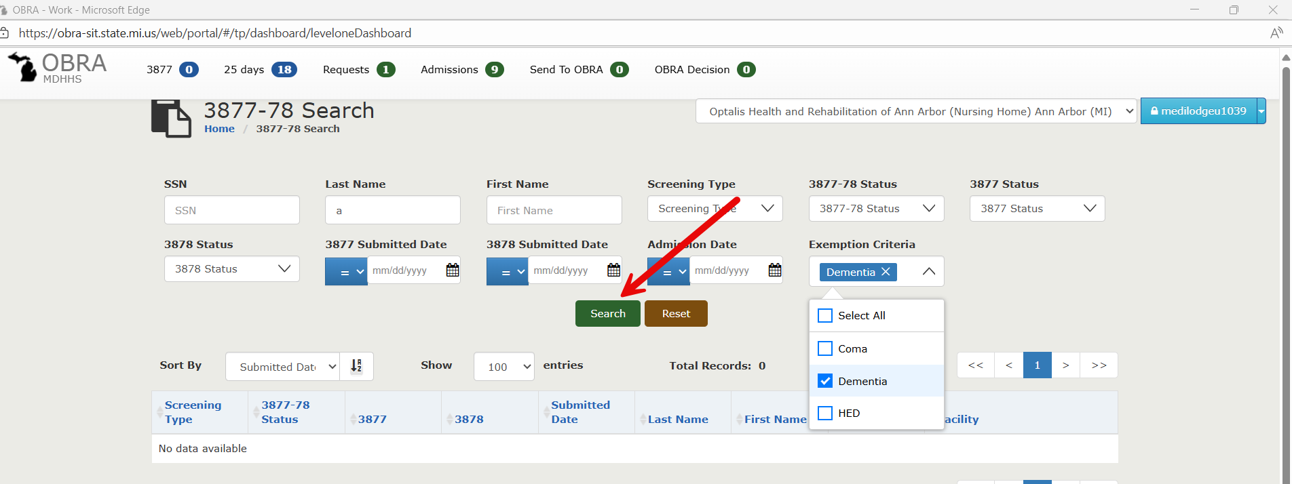

Step 3:  
Results displayed below. Sort by descending order of Submitted date.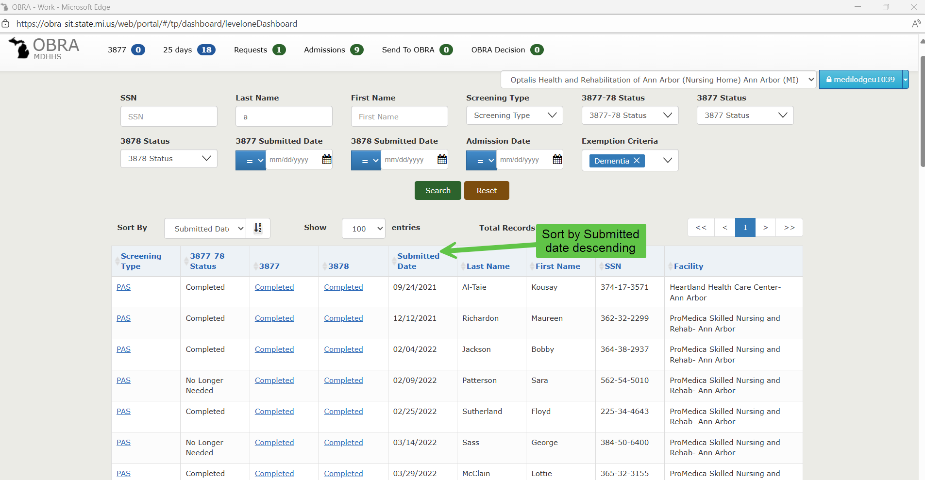

Step 4:

Click on the first record on the “PAS” link.

Step 5:

Lands on the 3877-78 Detail page. Scroll down and click on “3877 form” hyper link

Step 5:

3877 form opened in a new window. Click on “Print”. The print form should be captured and stored.

Step 6:

Navigate back to 3877-78 Detail Page. Click on 3878 form. (Repeat the same steps). The 3878 form will be printed a new window, capture the PDF..

Step 7:

Navigate back to 3877-78 Detail page, click on “View All”. Capture the PDF.

